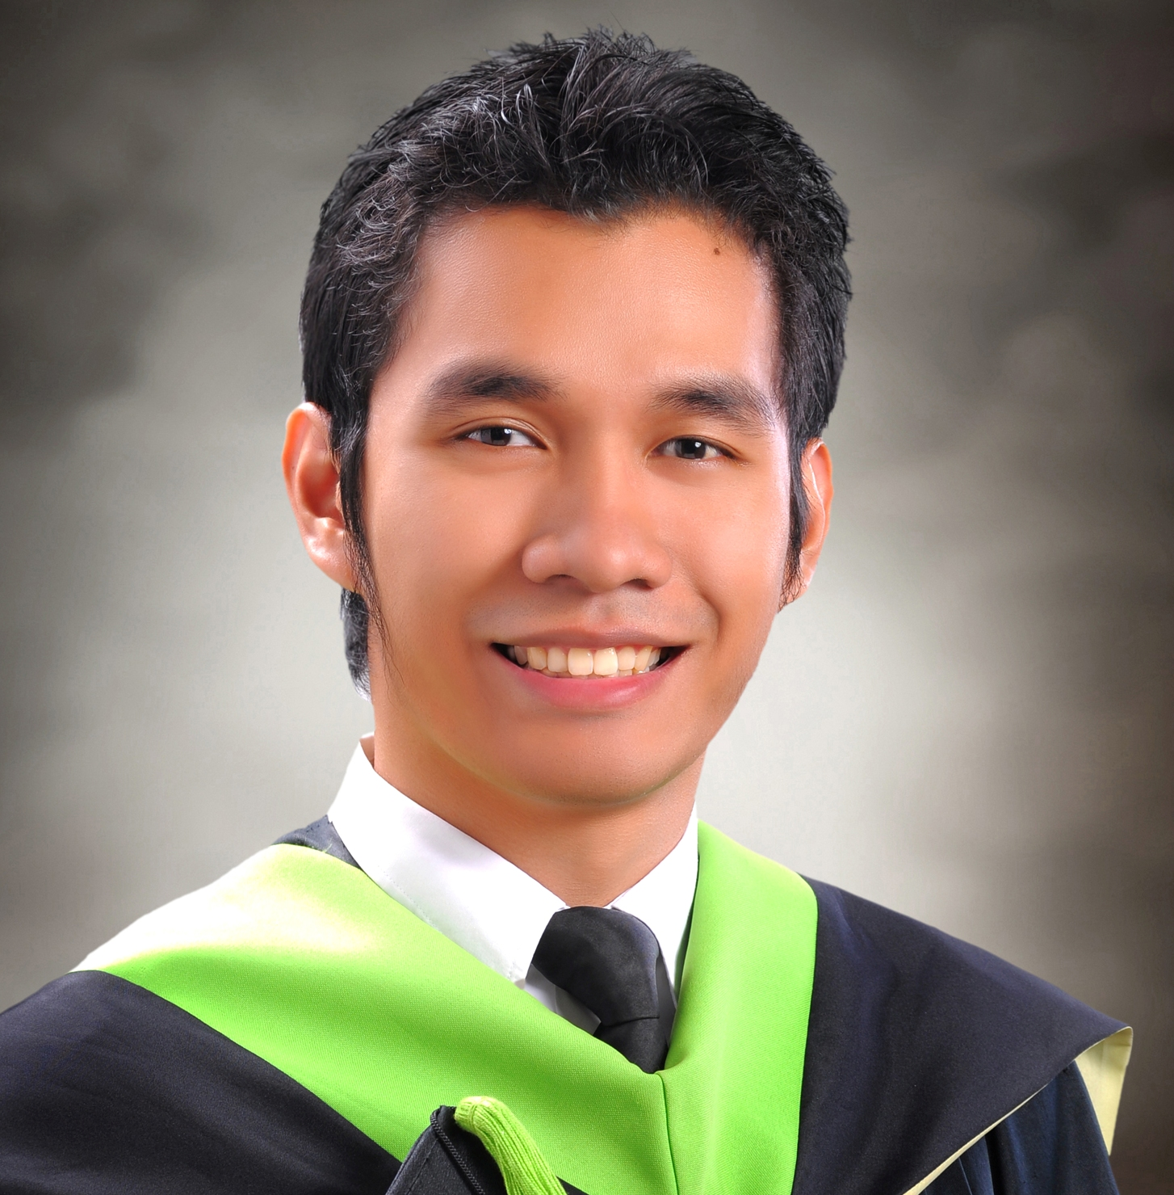
KENNY BELANDRES BIOL
#0263 Quezon National Highway,
Pajo, Lapu-Lapu City, Cebu
Contact # 340-0108 / 09425509197
kennybiol@yahoo.com

Personal Data:

Birth Date: October 2, 1991
Birth Place Cebu City
Status: Single
Languages: Cebuano, English, Filipino

Objective: To apply for a job position in your company to furthermore sharpen my skills in a competitive environment while helping to achieve greater heights for my future career and at the same time the company’s.

Skills:

- Creative and competitive in designing features in various areas of expertise
- Quick to learn
- Willing to work under pressure and for extended hours
- Adapts well to a mixture of individuals
- Team player
- Good communication and written skills
- Observant to details and oversights

Computer Skills

Operating Systems: Microsoft Windows
Internet Browsers: Google Chrome, Internet Explorer, Mozilla Firefox
Others: Adobe Photoshop, Microsoft Office, HTML, PHP, mySQL, C++ Programming, Troubleshooting

Education: B.S in Information and Communication Technology
University of San Carlos
Talamban, Cebu
June 2009 – March 2013

Formation School and Kiddies Learning Center
Uytengsu Compound, Osmeňa Blvd., Cebu city
June 2004 – March 2008

Work Experience:

Ripe Concepts
12th Floor Insular Life Building, Cebu Business Park, Cebu City
Quality Control/Designer Associate (Contractual)
November 2013 – December 2013

Philippine Long Distance Company (PLDT)
ML Quezon Nat’l Highway, Pajo, Lapu-Lapu City
MDF Assistant (Intern)
June 2012 – August 2012

Clicking Labs
8th Floor Crown 7 Building, Juan Luna Avenue, Mabolo, Cebu City
Quality Assurance (Intern)
August 2012 – October 2012

References:
Ms. Stephanie B. Polinar,
Faculty Member of the Department of Computer Science
University of San Carlos – Technological Center
Nasipit, Talamban, Cebu City
sbpolinar@yahoo.com.ph

Mr. Cyvir Ace M. Ramirez
Quality Control TL
Ripe Concepts, Insular Life Building, Cebu Business Park, Cebu City Contact # 09176271716

Mr. Briton H. Rabe
Part-time Faculty Member of the Department of Computer Science
University of San Carlos – Technological Center
Nasipit, Talamban, Cebu City
Contact # 09335011262

